Workshop 0 interaction design in a day

**Concept brainstorm**

1. [Free software is what keeps the networked world going](http://95theses.co.uk/?page_id=97)
   1. Adds
   2. Online
   3. Spam
   4. Shared
   5. Friends
2. Internet helps to share happiness
3. Sport
4. Life
5. Work
6. Meetings
7. Profit
8. [If the service is free then you are the product](http://95theses.co.uk/?page_id=113)
9. Ads
10. Data
11. Monitoring
12. Micro-transactions
13. Testing
14. On the Internet, attack is always easier than defence
15. Anonymous
16. Hacking
17. Emotions
18. DDOS
19. Virus
20. Keeping secrets is the way we preserve our privacy
    1. Password
    2. Hidden
    3. Protect
    4. Isolate
    5. Dissociate

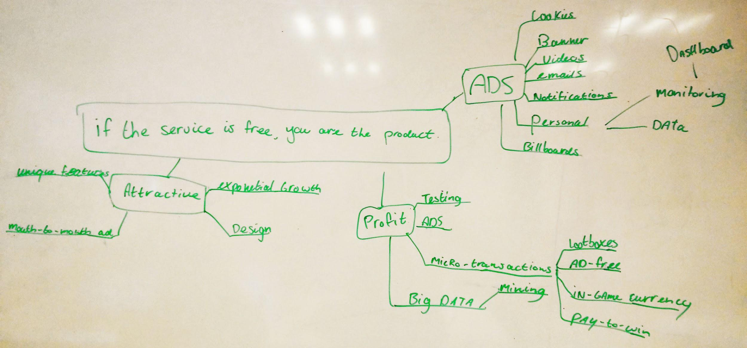

Questions:

1. Why do users choose free services over paid services?
2. Why do developers develop free apps?
3. What makes free services attractive?
4. How do companies make profit out of free services?
5. How do companies who make free services reach their target audience?
6. What happens to collected data from free services?
7. Are micro-transactions more profitable than paid services?
8. Which advertising method works the best for free services?

**Defining the problem**

**Topic: How do companies make profit out of free services?**

Design a free service to enable users to enjoy the service with less annoying advertisements.

**Describe the user**

1. What is your target demographic?

Age 12-25, Any gender .

2. Where do they live?

Western countries.

3. What industry do they work in?

Students.

4. How much do they earn?

Minimum wage.

5. What are their hobbies?

Gaming.

6. How do they get their information?

Internet, friends, social media.

7. How do they communicate?

Social media, mouth to mouth.

8. How do they think?

Look for free and fun stuff.

9. Who is important to them?

Friends, high rank players.

10. How can you best reach your target audience?

Social media, mouth to mouth.

11. What challenges do they face?

Annoying ads. Pay to win.

12. Can your concept help them with these challenges?

Yes, we’re solving their problems by redesigning advertisements to make them more fun and less annoying.

13. What pushes them to invest in the concept?

Cosmetic design to make it attractive. Innovative app design.

14. Who had these users before you?

Free to play mobile game developers. (Ketchapp)

15. What are their biggest objections to participate in your concept, service or product?

Swimming in a sea with alot of fish

**Paper prototype**

1. **Are the ads on the sideline annoying to the user?**
2. **Are the extra points not to much**
3. **Are the ads in half and end time annoying to the user?**
4. **Does the user see the advertising on the side line?**
5. **Wich advertising does the user like better, the choices for points or the movies add half time.**